# Homework 06

ME1020 – Engineering Mechanics

(a)

**x(cm) = 2t – 6t3 🡪 Eqn. 1**

Differentiating wrt time, we get

**vx(cm/s) = dx/dt = 2 – 18t2 🡪 Eqn. 2**

ax (cm/s2) = d2x/dt2 = dvx/dt

**= -36t 🡪 Eqn. 3**

∴At t = 5s,

Velocity of head = vx (at t = 5)

= 2 – 18*52 (From Eqn 2)

**= -448 cm/s**

Acceleration of head = ax (at t = 5)

= -36*5 (From Eqn 3)

**= -180 cm/s2**

(b)

Initial velocity of car = 20km/h = 50/9 = 5.555 m/s

Acceleration of car after 2 seconds = a = 3m/s2

First, let us see how long the car takes to reach the signal which is 100m away (say ‘t’seconds).

If this time is **less than 5 seconds** (time taken to turn from yellow to red), that means **he reaches the signal before it turns red**. If the calculated time is **more than 5 seconds**, he **doesn’t reach the signal on time**.

Total distance = (vinitial)(2s) + (vinitial)(t-2) + 1/2 a(t-2)2

100m = (5.555 m/s)(2s) + (5.555)(t-2) + 1/2 (3 m/s2)(t-2)2

1.5(t-2)2 + 5.555(t-2) – 88.89

Solving, we get

(t-2) = 6.065s

**t = 8.065s > 5s**

∴The car doesn’t reach the signal on time.

**The velocity of the car when it reaches the signal = vinitial+ a(t-2)**

**= 5.555 + 3(6.065)**

**= 23.75 m/s**

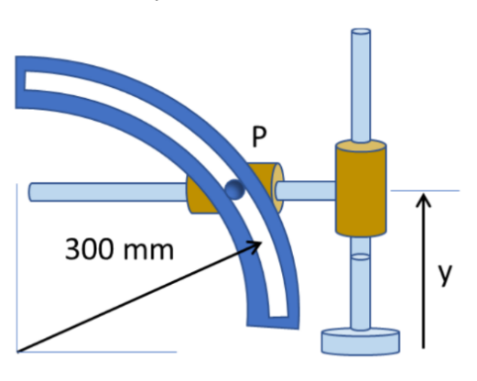2.

(a)



**y = 300sinθ 🡪 Eqn 1**

Differentiating wrt t,

**dy/dt(mm/s) = (300cosθ)dθ/dt 🡪 Eqn 2**

Differentiating again wrt t,

**d2y/dt2(mm/s2) = 300[(cosθ)(d2θ/dt2) – (sinθ)(dθ/dt)2] 🡪 Eqn 3**

When y = 200mm, sinθ = y/300 = 2/3 = 0.666(From Eqn 1)

∴cosθ = √5/3 = 0.745

tanθ = 0.894

At y = 200mm,

(i)dy/dt = 200mm/s (Given)

∴300cosθdθ/dt = 200

d**θ/dt = 2/(3cosθ) [Eqn 1]**

**= 0.894 rad/s**

∴ Radial acceleration (towards centre) at point P (aR) = (dθ/dt)2R

= **240 mm/s2**

(ii)d2y/dt2 = 0

(cosθ)(d2θ/dt2) = (sinθ)(dθ/dt)2

d2θ/dt2 = 0.894(0.894)2

= **0.7155 rad/s2 (Angular acceleration)**

∴Tangential acceleration (aT) = (d2θ/dt2)R

= 0.7155x300

**= 214.65 mm/s2**

∴Net acceleration = √(ar2 + aT2)

**= 321.98 mm/s2**

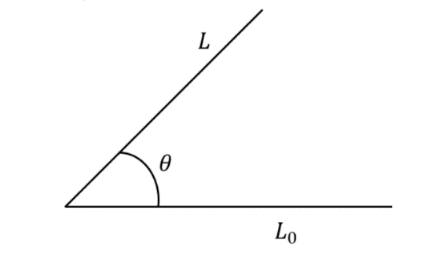

(b)

α = dω/dt = 2-1.5t

dω = (2 – 1.5t)dt

Integrating with suitable limits,

∫5ω(t) dω = ∫0t (2 – 1.5t)dt

ω(t) – 5 = 2t – 0.75t2

**ω(t) = 5 + 2t – 0.75t2 🡪 Eqn. 1**

dθ/dt = ω(t) = 5 + 2t – 0.75t2

dθ = (5 + 2t – 0.75t2)dt

Integrating with suitable limits,

∫0θ(t)dθ = ∫0t(5 + 2t – 0.75t2)

**θ(t) = 5t + t2 – 0.25t3 🡪 Eqn 2**

∴ω(3s) = 5 + 2x3 – 0.75x32

**= 4.25 rad/s**

**θ(3s) = 5x3 + 32 – 0.25x33**

**= 17.25 rad**